Lab Report – SQL Injection on Juice Shop

Introduction
In this lab I used OWASP Juice Shop, which is a purposely vulnerable Ib application. The aim was to perform a SQL Injection attack on the login page and then try to apply mitigation using Nginx with ModSecurity (Ib Application Firewall). I Ire able to complete the attack part successfully, but the WAF setup did not work properly. So this report covers the attack stage only.

Threat Scenario
The target of our attack was the login page of Juice Shop running on http://localhost:3000/#/login. The attacker’s goal was to bypass login authentication without knowing the correct password. The type of attack chosen was SQL Injection, which is one of the most common and dangerous Ib application vulnerabilities.

Attack Execution
The attack was done step by step. First, I opened the Juice Shop application in the browser and Int to the login page. In the email field I entered the payload ' OR 1=1--. In the password field I typed anything, even a blank value. After clicking the login button, the application alloId us to log in successfully without valid credentials. This proved that the backend query was vulnerable because it directly concatenated user input into the SQL statement.

Evidence Collected
I collected evidence of this attack. Screenshots Ire taken showing the login page with the payload entered and another screenshot showing the successful login into the application. The observation was clear: the query logic was broken by our input. Normally, the login checks if the email and password are correct. But our input changed the query to always return true (OR 1=1), and the -- symbol commented out the rest of the query. Because of this, the application gave access without verifying the password.

Mitigation Attempt
After the attack, I tried to set up Nginx with ModSecurity WAF using Docker Compose. Juice Shop started correctly on port 3000, and the Nginx WAF container started on port 8080. HoIver, when I tried to access Juice Shop through the WAF, I received error pages from Nginx. This shoId that the proxy was not connecting properly to the backend Juice Shop service. Therefore, the mitigation part is not successful yet.

Conclusion
The SQL Injection attack on Juice Shop was successful and clearly demonstrated how dangerous this vulnerability can be. I Ire able to bypass login authentication with a simple payload. The mitigation attempt using Nginx and ModSecurity is pending because of configuration issues. The next step will be to fix the Nginx proxy setup and then test again with the same payload to confirm that the WAF blocks the attack.

INSTALLATION
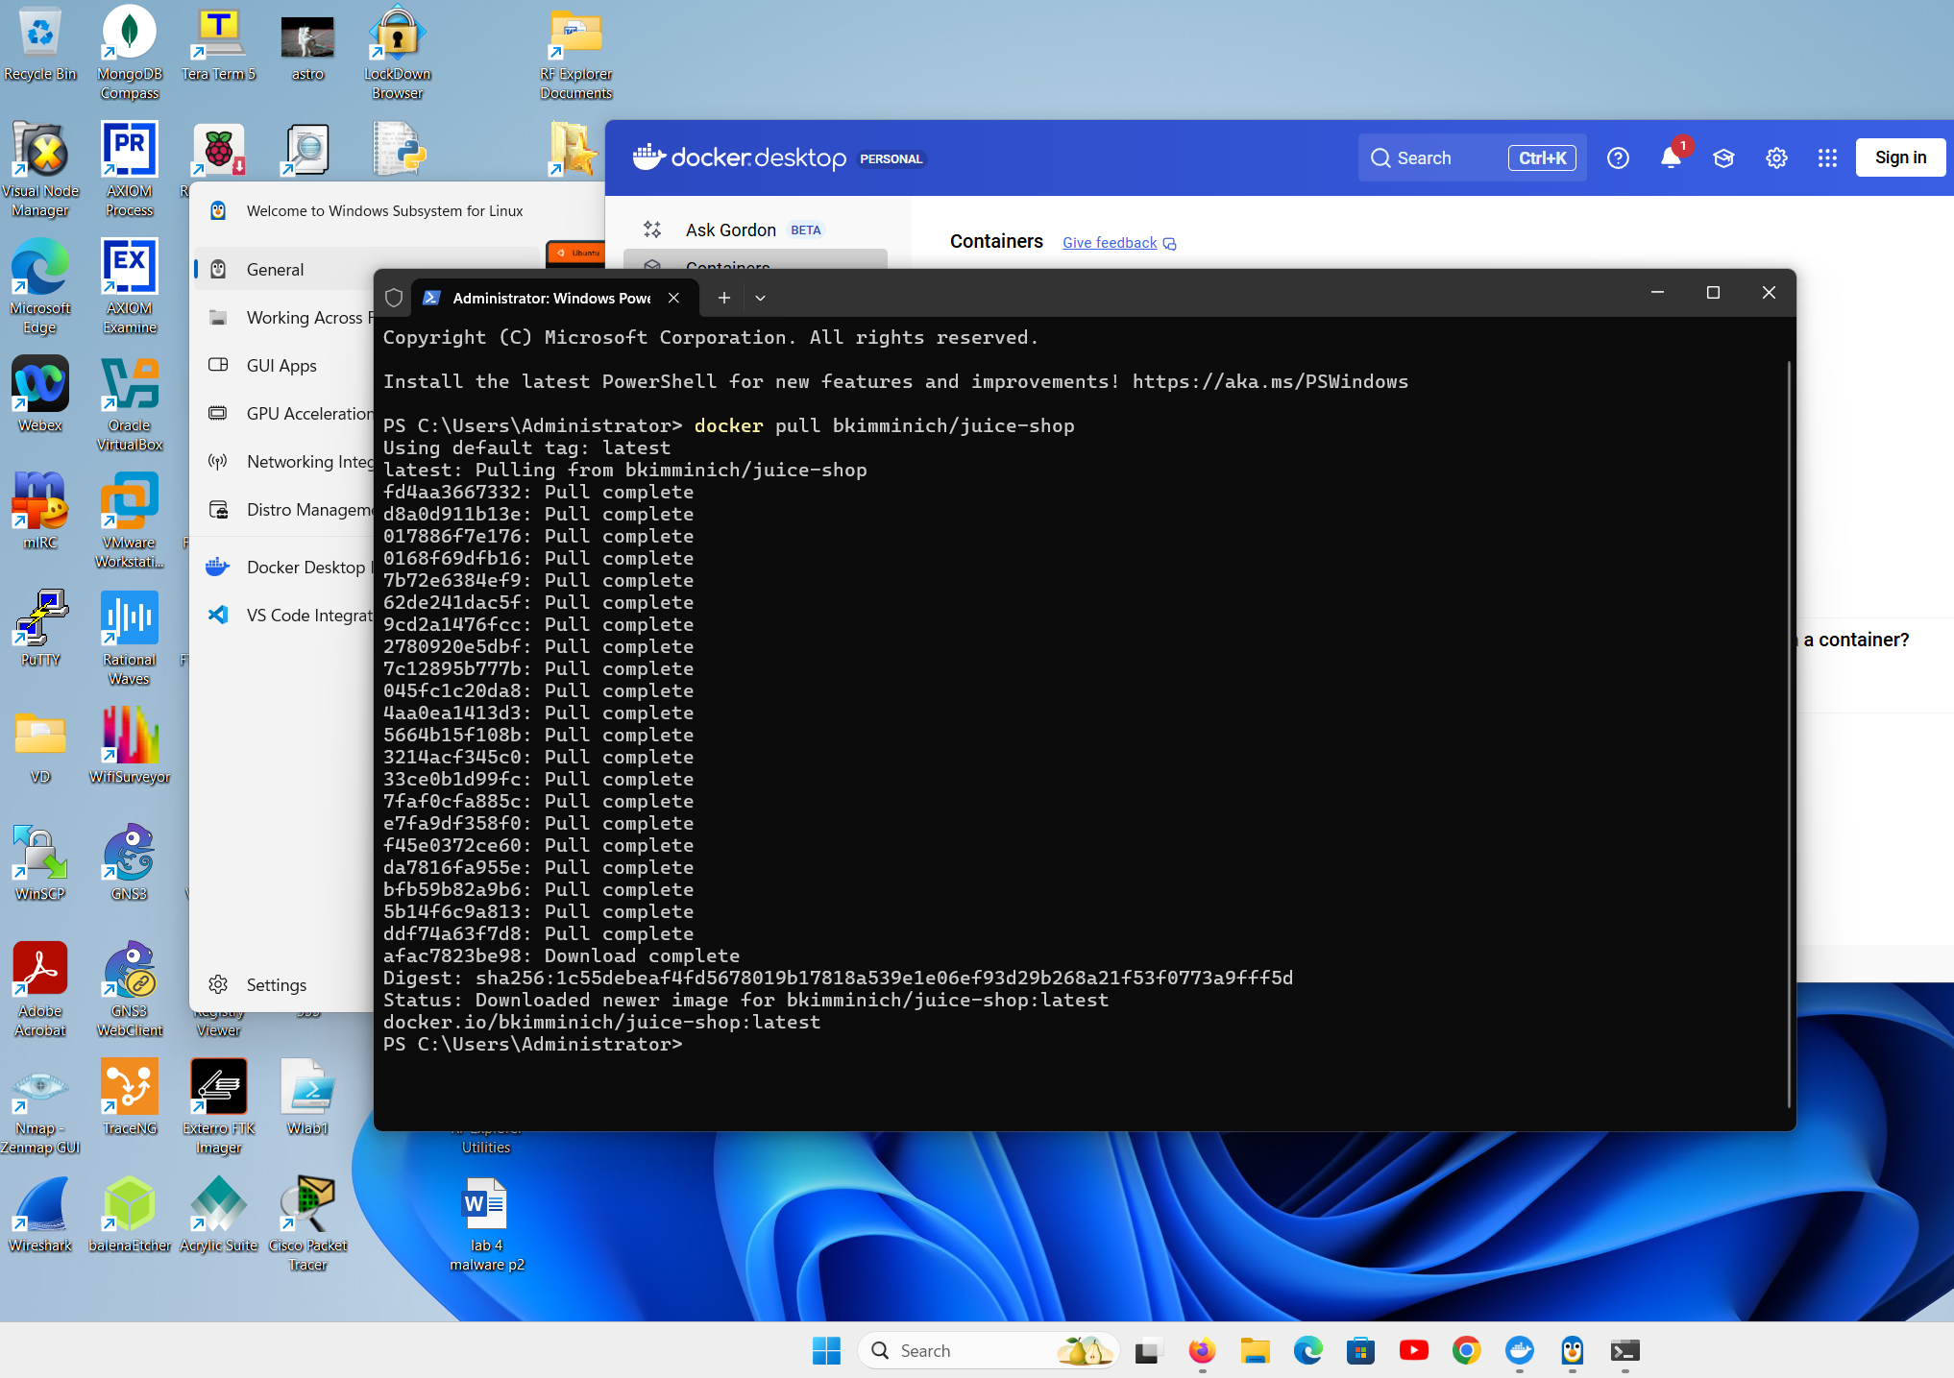

Running Docker
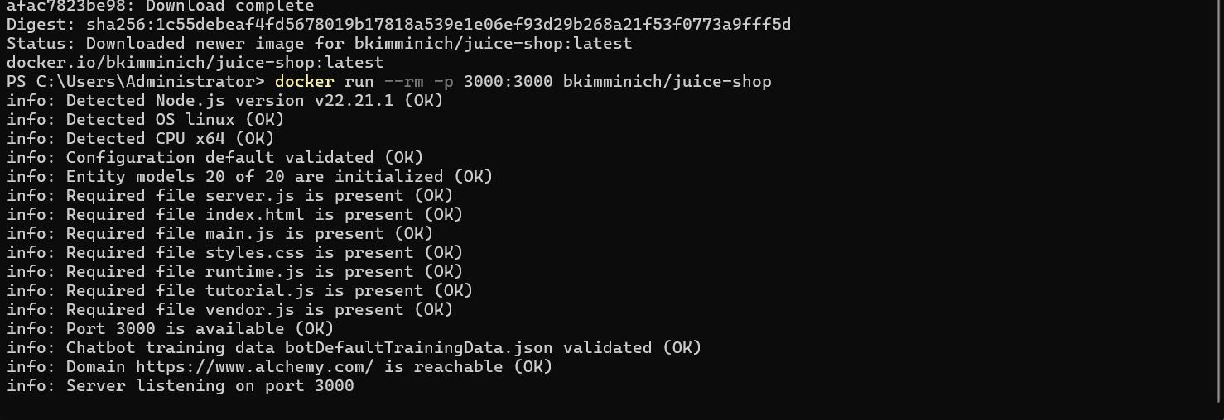
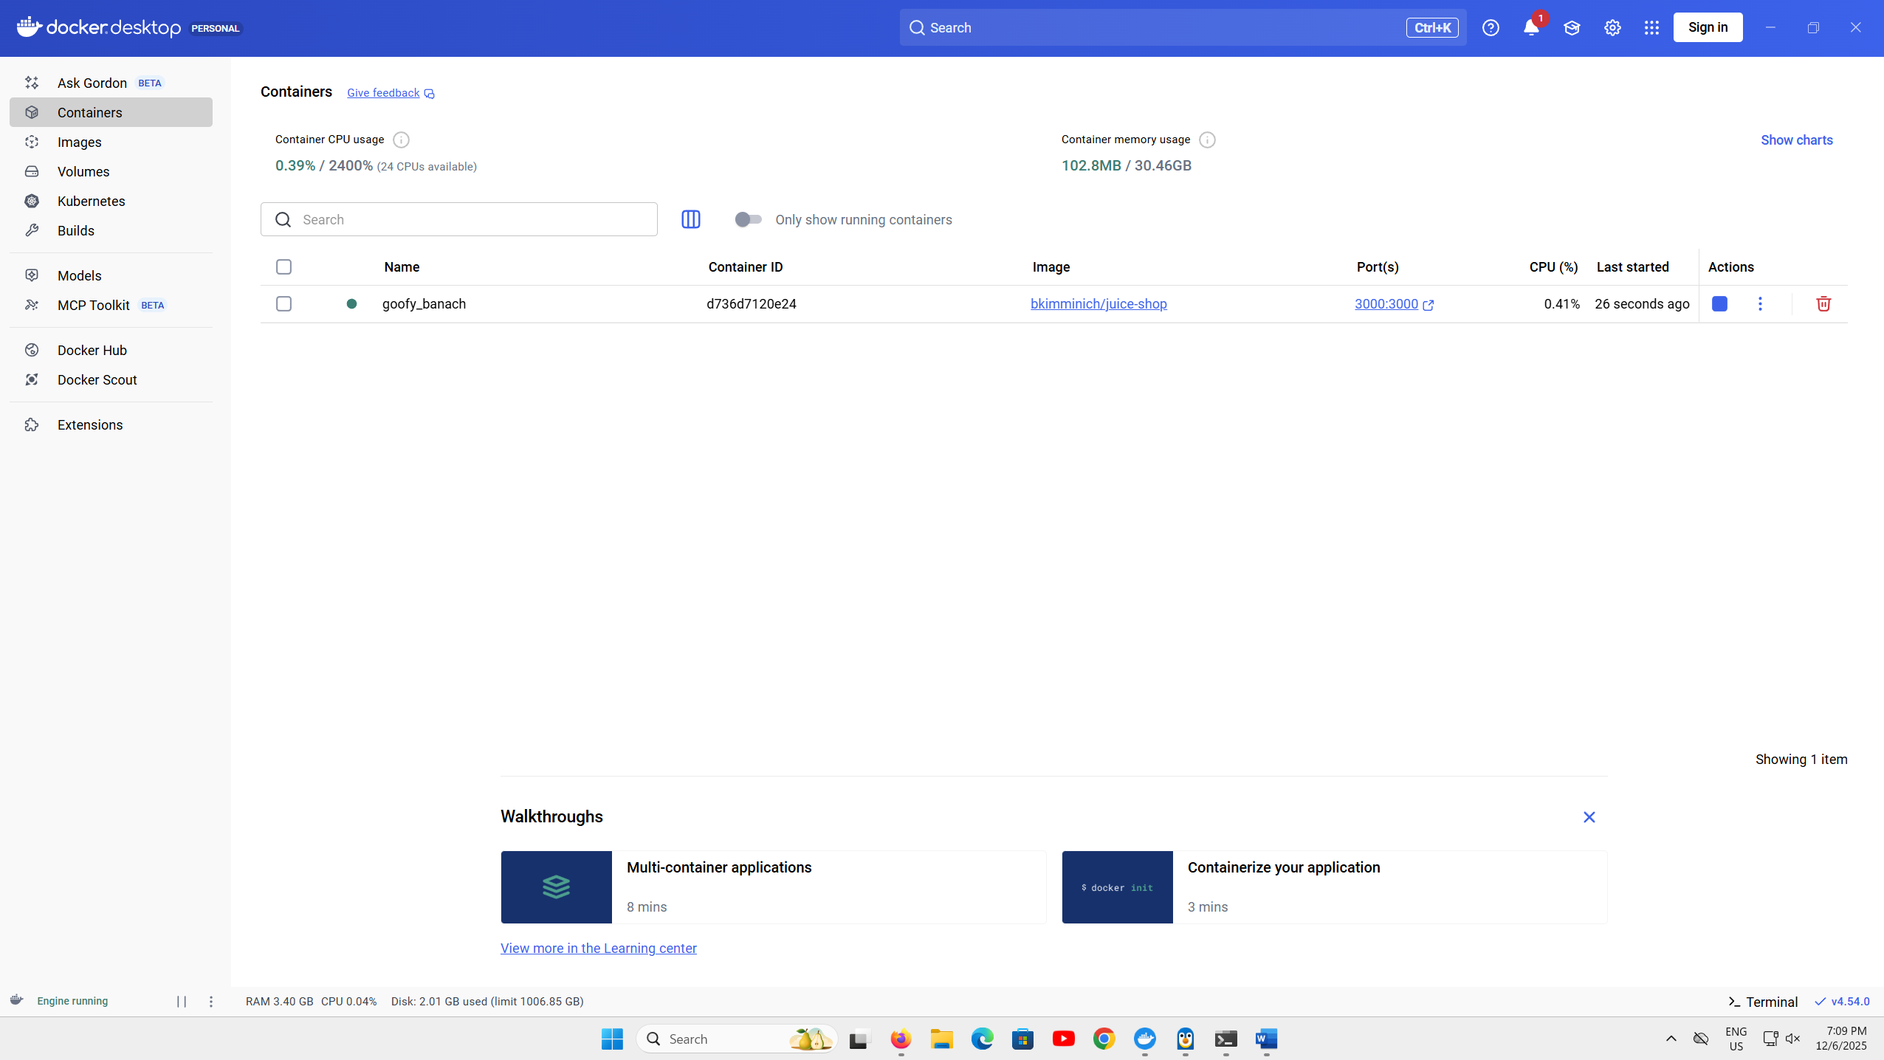

Accessing the Juice shop
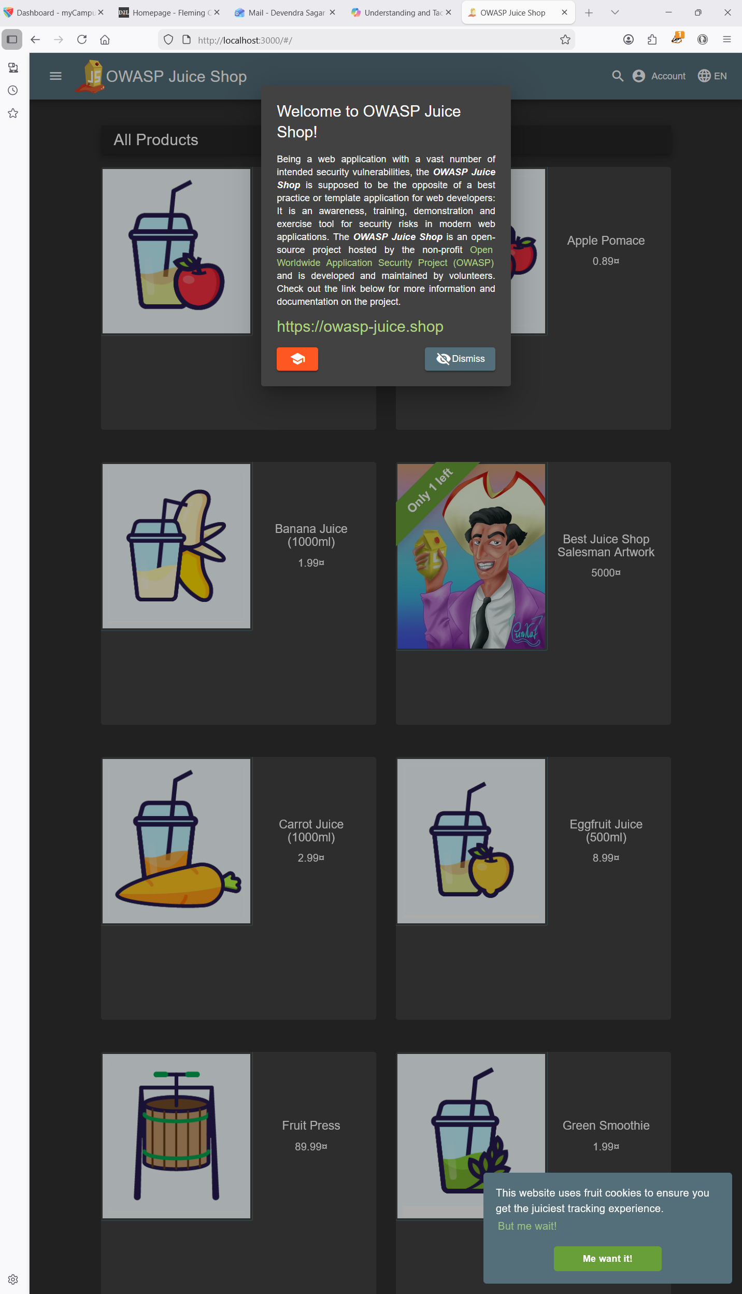

Attacking
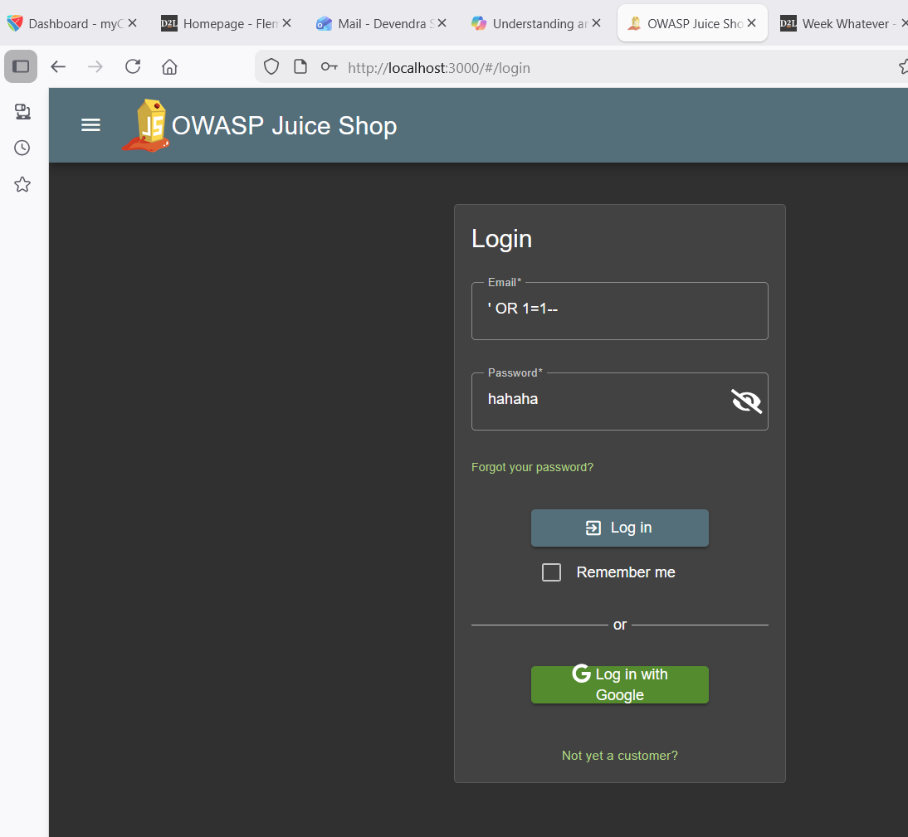

Successful attack execution
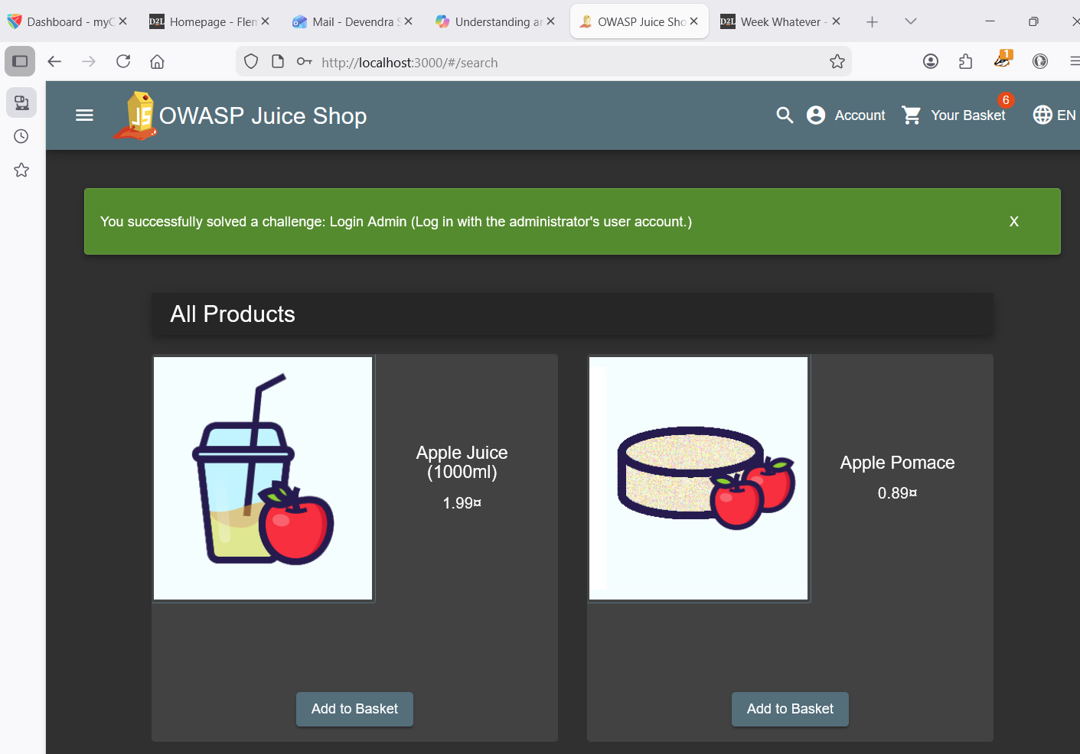

Failed Debugging
